Public GIT: https://github.com/Isaacthebomb306/Isaac_bonello_dgd6.2A_databases

Public API: https://isaac-bonello-dgd6-2-a-databases.vercel.app/docs

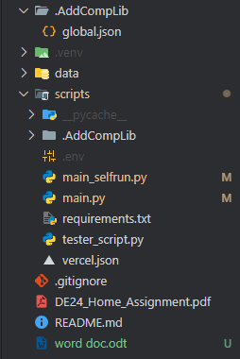
Task 1:

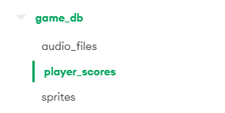
Task 2:

Task 3:
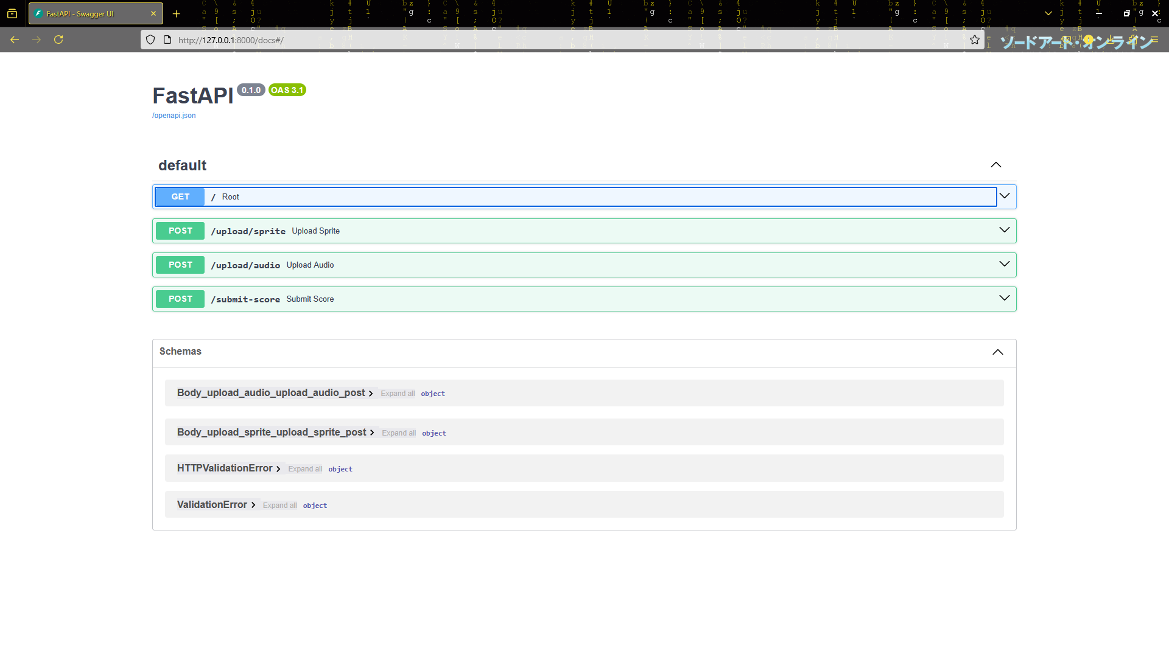
A:

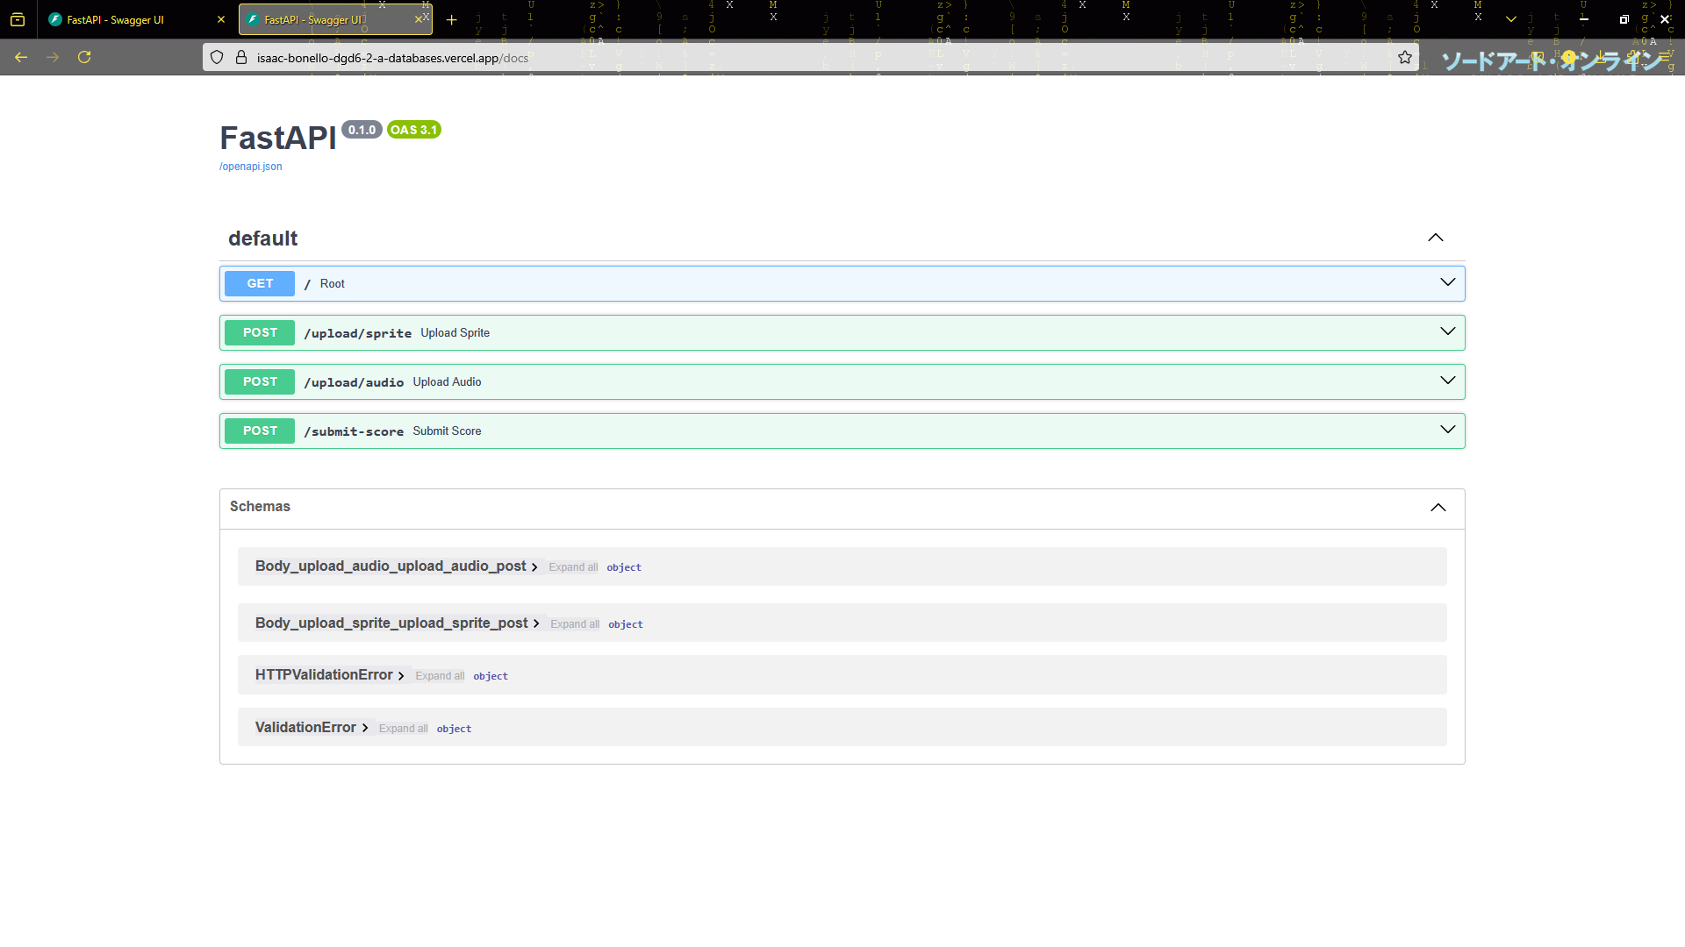
B:

Task 4:
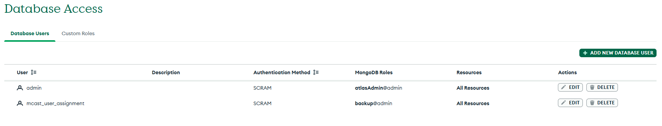
A:

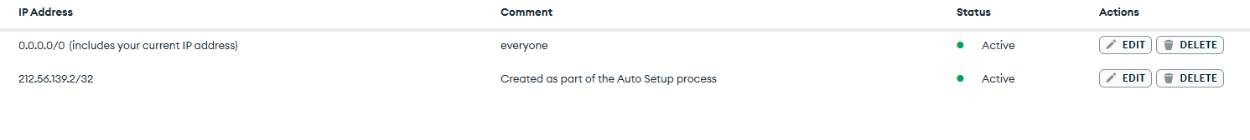
B:

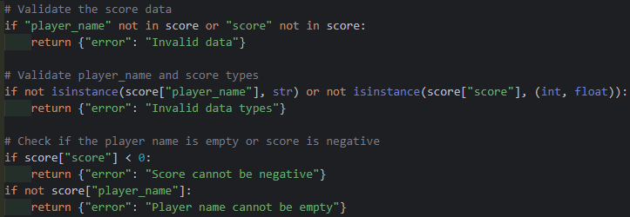
C:

